28. Implement strStr()

class Solution:

def strStr(self, haystack: str, needle: str) -> int:

if needle != "":

result = haystack.find(needle)

return result

elif needle =="":

return 0

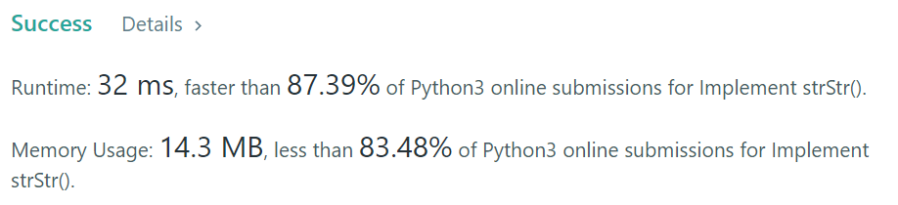

Others:

class Solution(object):

def strStr(self, haystack, needle):

"""

:type haystack: str

:type needle: str

:rtype: int

"""

for i in range(len(haystack) - len(needle)+1):

if haystack[i:i+len(needle)] == needle:

return i

return -1